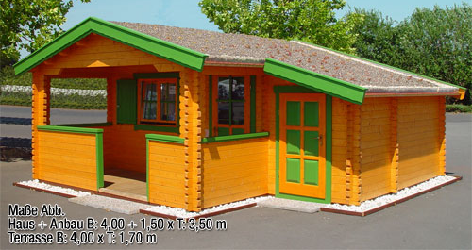 | 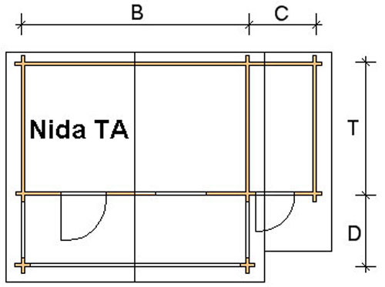
 | 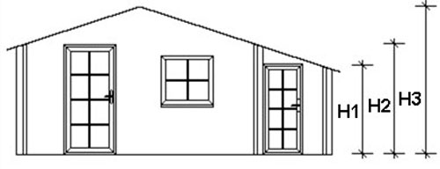

Nida-TA Log Cabin
Roof projection: Front 0.70 m
Back 0.20 m
Side 0.30 m

Consists of:
Walls: 45 mm or (60 mm glued) double tongue and groove logs from Northern Pine
Floor: 20 mm tongue and groove floor boards on the impregnated base frame
Roof: 20 mm tongue and groove roof boards on the roof beams
Door: 1 glued cartridge door 90/196 with seal
1 glued cartridge door 90/193 with seal
Windows: 1 double-glazed 80/94 tilt ‘n‘ turn unit

Size (m) |  |  |  | Log Cabin Height (m) |  |  | Price (£) |  | Optional Extras
 |  |  |  |  |  |  |  |  | Roof Insulation (£) |  | Shingles (£)
B | T | C | D | H1 | H2 | H3 | 45 | 60 | 45 | 60 | Shingles (£)
3.0 | 3.0 | 1.5 | 1.6 | 1.67 | 2.08 | 2.50 | 2911 | - | 148 | - | 170
3.0 | 4.0 | 1.5 | 1.6 | 1.67 | 2.08 | 2.50 | 3330 | - | 177 | - | 219
4.0 | 3.0 | 1.5 | 1.7 | 1.67 | 2.08 | 2.63 | 3330 | - | 177 | - | 219
4.0 | 4.0 | 1.5 | 1.7 | 1.67 | 2.08 | 2.63 | 3892 | 4792 | 213 | 217 | 238
4.0 | 5.0 | 1.5 | 1.7 | 1.67 | 2.08 | 2.63 | 4283 | 5172 | 241 | 245 | 295
5.0 | 4.0 | 1.5 | 1.7 | 1.67 | 2.08 | 2.63 | 4283 | 5172 | 250 | 252 | 295
5.0 | 5.0 | 1.5 | 1.7 | 1.67 | 2.08 | 2.63 | 4690 | 5580 | 282 | 283 | 320

Extras:

Single window £83
Double window 1200/940 £124
Single door £159
Double door 1700/1970 £267

